2.8 What Is an Integer? P. 74

Pre- Chat

How do we describe temperature that is greater than 0 ⁰ C?

+ _______

How do we describe temperature that is below 0 ⁰ C?

-_______

Use a positive or negative integer to represent each situation:

-Eight degrees above zero

-Ten degrees below zero

-Parking three levels below ground

-Twenty-three metres above sea level in Victoria BC

-a loss of 16 dollars

-taking four steps backwards

2.8 What Is an Integer? P. 74

**Definitions:**

**Integers:** numbers that contain + or – signs.  
eg. + 24 and -18

The + sign in front of a number tells us that it is a **positive integer**

The – sign in front of a number tells us that it is a **negative integer**

**Opposite Integers:** the same distance from 0, but are opposite signs (or on opposite sides of zero on number line)   
Eg. +2 and -2 are opposite integers

We use integers to represent quantities that have both size and direction.   
Eg. Mark saved $25 can be represented as + $25  
Eg. A scuba diver swam to a depth of 50 m can be represented as – 50 m

**We can use coloured tiles to represent integers**

One yellow tile represents +1



One red tile represents -1



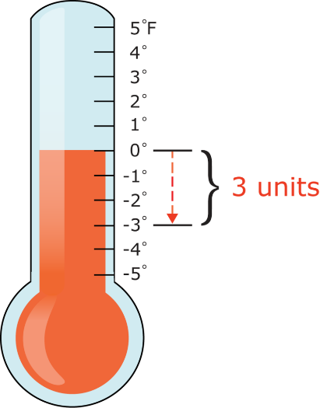To model + 6 , we use 6 yellow tiles



To model -5 we use 5 red tiles



We can show integers on a horizontal or vertical number line.

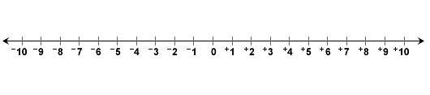



The numbers to the left of 0 on the number line are negative and the numbers to the right are positive.







**Homework:** p.76: 1, 2 aceg, 3, 4, 5, 6, 8 Bonus: 9, 10