2.9 Comparing and Ordering Integers

Warm up:

Elevation is the height above or below sea level. This elevation influences climate and how people live. For example, some crops will not grow at elevations above 5300 m.

Below are some examples of extreme elevations around the world:

|  |  |  |
| --- | --- | --- |
| Place | Elevation | Integer |
| Vinson Massif, Antarctica | 4897 m above sea level |  |
| Dead Sea, Israel/Jordan | 411 m below sea level |  |
| Bottom of Great Slave Lake, Canada | 458 m below sea level |  |
| Mt. Nowshak, Afghanistan | 7485 m above sea level |  |
| Challenger Deep, Pacific Ocean | 10 942 m below sea level |  |

What is the integer for each elevation?

Order these elevations from least to greatest on a piece of paper.

Compare with your partner.



* Print comparing integers on back of notes

2.9 Comparing and Ordering Integers



We can use a number line to order integers.



* Use the symbol > and < to show order. The symbol always points to the lesser number… and if you picture it as pac man- it eats the bigger number.



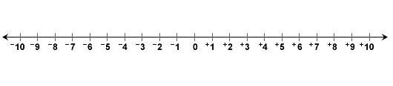



+ 5 is to the ________________ of +3 on a number line.



+ 5 is___________________ than +3, so we write: +5 ______ +3



+3 is __________________ than + 5, so we write: +3 ______ +5







+ 3 is to the ________________ of -4 on a number line.



+3 is _______________ than -4, so we write: +3_______ -4



-4 is _______________ than +3, so we write: -4 _______ +3







-3 is to the ________________ of -1 on a number line.



-3 is _____________ than -1, so we write: -3 _____ -1



-1 is ______________ than -3, so we write: -1 _____-3



* To order the integers 0, +1,+3 and -5, draw a number line with these values included. Mark each integer on the number line.





The integers increase from left to right. So, the integers from least to greatest are:



HW: p. 80 # 1-10 + [Comparing Integers worksheet](C:\\Users\\Owner\\Dropbox\\Math 7\\compare-positive-negative-1integers.pdf)