Deforestation by fire
Definition – Deforestation by forest fires can occur naturally, like lightning lightning strikes; through human carelessness – cigarettes, campfires, etc.; or indirectly through human activity that contribute to climate change.
A forest fire in southern BC  From Van City Buzz  http://www.vancitybuzz.com/2015/06/heat-wave-triggers-campfire-ban-for-b-c-south-coast/ |  | Details  “As the climate warms, moisture and precipitation levels are changing, with wet areas becoming wetter and dry areas becoming drier. Higher spring and summer temperatures and earlier spring snow-melt typically cause soils to be drier for longer, increasing the likelihood of drought and a longer wildfire season.  These hot, dry conditions also increase the likelihood that, once wildfires are started by lightning strikes or human error, they will be more intense and long-burning.”  Impact  “The costs of wildfires, in terms of risks to human life and health, property damage, and state and federal dollars, are devastating, and they are only likely to increase unless we better address the risks of wildfires and reduce our activities that lead to further climate change.”  From http://www.huffingtonpost.ca/2014/09/05/canada-deforestation-worst-in-world_n_5773142.html
Reflection question: When are forest fires beneficial to a plant/tree species? When are they not?

Deforestation by humans
Definition: the clearing or logging of forests for human use.
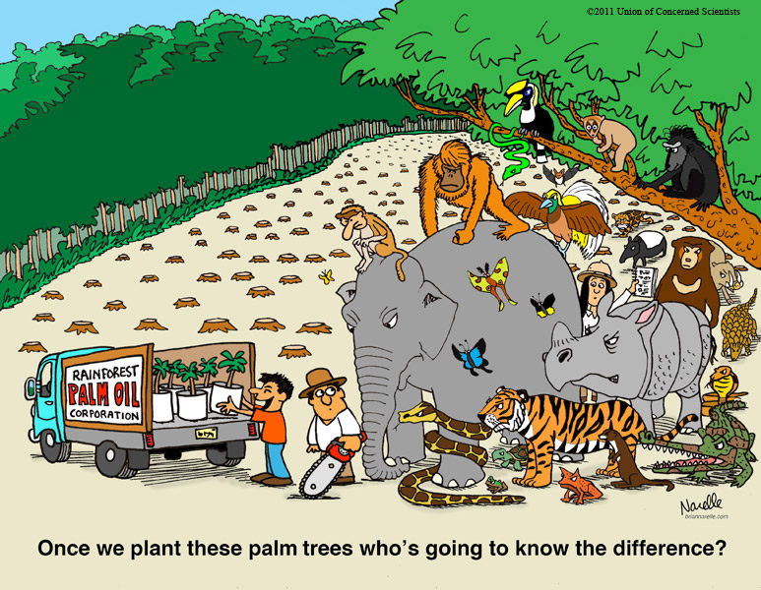  From Union of Concerned Scientists  http://www.ucsusa.org/publications/pulse/cartoon-september-2012.html#.VsuLSE8UW70 |  | Details  Forests around the world are under threat from deforestation, jeopardizing the many benefits rainforest provide. Deforestation comes in many forms, including fires, clear-cutting for agriculture, ranching and development, unsustainable logging for timber, and degradation due to climate change.  Impact  This impacts people’s livelihoods and threatens a wide range of plant and animal species. Some 46-58 thousand square miles of forest are lost each year—equivalent to 48 football fields every minute.  http://www.worldwildlife.org/threats/deforestation
Reflection question: What adaptation would one of the rainforest animal species have to make to be able to survive in this new environment? Behavioral? Physiological? Structural? What would the result be if a species was unable to adapt?

Introduced/Alien Species – plant
Definition: An introduced species (also known as an exotic species) is an organism that is not native to the place or area where it is considered introduced and instead has been accidentally or deliberately transported to the new location by human activity. It may or may not become invasive.
From Science Daily
https://www.sciencedaily.com/terms/introduced_species.htm
Scotch Broom  https://www.for.gov.bc.ca/hra/plants/biocontrol/bcmatrix.htm |  | Details  Scotch Broom was introduced to BC’s shores by Captain Walter Colquhoun Grant, who brought it to Sooke from Hawaii. The broom plant itself originates in the Mediterranean which is why it does so well in the southern coastal climate of BC.  Originally planted along highways to prevent soil erosion, Scotch broom has spread far and wide and is now considered an invasive plant.  Impact  Once Scotch Broom becomes established, it’s tough to remove. It invades rangelands, replaces forage plants, causes allergies in people, and is a serious competitor to conifer seedlings. The plant grows rapidly and spreads quickly, causing damage to the environment, economy and our health. It is the second greatest threat to biodiversity after habitat loss, according to the International Union for Conservation of Nature (IUCN).  3 on the Threat Meter  from Invasive Species Council of British Columbia  http://bcinvasives.ca/  and Aliens among us.
“Many volunteer groups work together each year to remove Broom from at-risk areas. It’s hard work but worth the effort, because native species are thriving again in these places.”
Aliens Among Us
Reflection question: What survival need is removed from the native species by the invasive species? What resource are the two species competing for?

Invasive species – animal
Definition: an invasive species is an alien species that causes harm to an ecosystem. Invasive species have three mafor characterisics
- rapid reproduction;
- few predators, parasites or diseases to keep their population in check; and
- the ability to thrive in their new home.
From Aliens Among Us
Zebra and quagga mussels  from Invasive Species Council of British Columbia  http://bcinvasives.ca/ |  | Details  These small mussels are native to lakes in eastern and western Asia. They found their way to North America in the late 1980s in the ballast water of ships. They have been found in the Great Lakes of Ontario and Quebec and some areas of the US. They are not in BC …yet!  Impact  These mussels can attach themselves to practically anything and are very difficult to remove once they do. They grow quickly and can quickly encrust boat hull, clog engines, and block water pipes and outfall pipes.  5 on the Threat Meter
Reflection questions: How do these invasive species impact humans? What leads to the rapid growth of these species’ population?

Climate change - land
Definition Climate change is a change in the typical or average weather of a region or city. This could be a change in a region's average annual rainfall, for example. Or it could be a change in a city's average temperature for a given month or season.

Climate change is also a change in Earth's overall climate. This could be a change in Earth's average temperature, for example. Or it could be a change in Earth's typical precipitation patterns.

Potato farmer in Richmond, BC  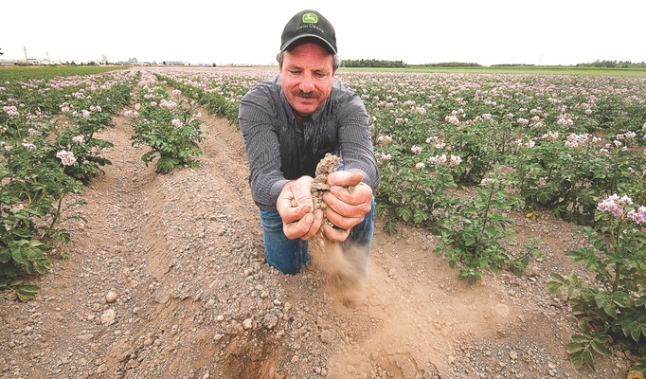 |  | Details  Scientists have warned that the world's climate has changed a lot, and has affected many living and non-living things.  Many places that were warmer are now getting colder, and many colder regions are getting much more colder or even warmer (know as Global Warming).  Impact (a few examples)  - Global warming causes thermal expansion of land and water.  - Changing climate may also cause the weather to become more extreme, be it droughts or violent storms and heavy rain.  - Climate change also distorts the natural habitats and lives of many plants and animals. For example, the survival of polar bears and penguins in icy regions are in danger, as they cannot survive anywhere else. Other plants and animals in hot regions will die if temperatures suddenly become too cold for them.  From eschool today  http://www.eschooltoday.com/climate-change/effects-of-climate-change.html
Reflection question: What adaptation would a food plant species have to make to be able to survive in this new environment? Physiological? Structural? What would the result to humans be if the food species was unable to adapt?

Habitat Fragmentation – BC

Definition: Habitat fragmentation is the division of large, continuous habitats into smaller, more isolated remnants.

http://www.els.net/WileyCDA/ElsArticle/refId-a0021904.html
From Canadian Parks and Wilderness Society  http://cpawsbc.org/campaigns/boreal-caribou |  | Details  The caribou in northeast B.C. live in a forest that has been heavily fragmented by oil and gas and countless roads.  Impact  The caribou are having difficulty surviving because they are not able to forage freely. Much of their habitat has been degraded and they are in danger of being hit by traffic when they attempt to cross road.
Reflection question: What adaptation would this forest animal have to make to be able to survive in its changed environment? Behavioral? Physiological? Structural? What would the result be if this species was unable to adapt?

Over exploitation – Atlantic Canada
Definition: Overexploitation means harvesting species from the wild at rates faster than natural populations can recover. Overfishing and overhunting are both types of overexploitation. Currently, about a third of the world's endangered vertebrates are threatened by overexploitation.

Atlantic Cod  From 1000 days for the planet  http://sedna.radio-canada.ca/en/biodiversity/problematics/143/overexploitation |  | Details  For over five centuries, the Atlantic cod, abundant in the North Atlantic, supported generations of families. In 1968, 800,000 tons of cod were fished out of the waters around Newfoundland! Then, the catch began to decrease and to yield increasingly younger and smaller specimens. Cod fishing was forbidden in 1992: the cod population was experiencing a freefall.  Impact  From one day to the next, thousands of fishermen were deprived of their livelihood. In spite of this measure, it is estimated that the stocks of Atlantic cod are only about 1% of what they were 30 years ago.
Reflection question: What other species (besides humans) have been affected by the reduction of the Atlantic Cod?

Introduced species – plant

Definition: An introduced species (also known as an exotic species) is an organism that is not native to the place or area where it is considered introduced and instead has been accidentally or deliberately transported to the new location by human activity.

https://www.sciencedaily.com/terms/introduced_species.htm
Purple loosestrife  From Aliens Among Us |  | Details  Purple loosestrife is a woody half-shrub, wetland perennial that has the ability to out-compete most native species in BC’s wetland ecosystems. It arrived on the eastern shores of North America in the ballast water from a European ship. In 1916, a Port Alberni resident planted the bright beast in the backyard garden … and the rest is history!  Impact  Dense stands of purple loosestrife threaten plant and animal diversity. They can choke out potentially rare and endangered species of native plants while dominating the area to the point of creating a monoculture. Plants holds little food value, cover and nesting material for animals, and leads to a reduction in habitat diversity. This can lead to the extirpation of the animal from its natural habitat.  It is a 4 on the Threat Meter – nasty!
Reflection question: What survival need is removed from the native species by the invasive species? What resource are the two species competing for?

Climate change - ocean
Definition Climate change is a change in the typical or average weather of a region or city. This could be a change in a region's average annual rainfall, for example. Or it could be a change in a city's average temperature for a given month or season.

Climate change is also a change in Earth's overall climate. This could be a change in Earth's (or the ocens’) average temperature, for example. Or it could be a change in Earth's typical precipitation patterns.
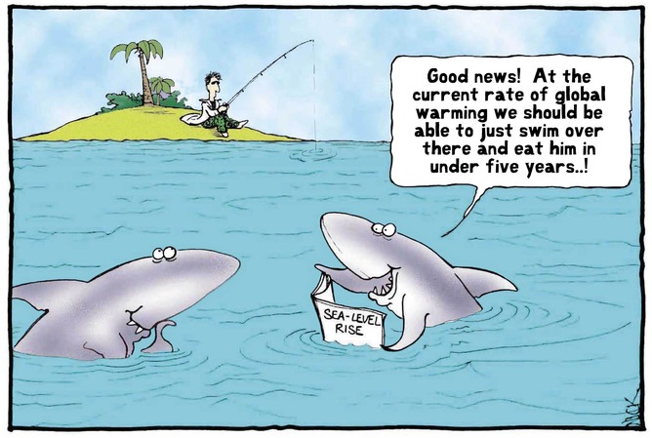 |  | Details  Scientists have warned that the world's climate has changed a lot, and has affected many living and non-living things. Many places that were warmer are now getting colder, and many colder regions are getting much colder or even warmer (known as Global Warming).  Impact  - It causes ice sheets to melt in icy regions of the world and mountain tops. Large volumes of melted ice (water) then flows down into streams, rivers, lakes and seas. The result is rising sea and water levels, causing floods and massive destruction to low-lying towns and cities along water bodies.  - Extreme changes in temperature makes people suffer breathing difficulties, headaches, body rashes and other illnesses.  From eschool today  http://www.eschooltoday.com/climate-change/effects-of-climate-change.html
Reflection questions: How does climate change impact marine animal species? What adaptations would marine species have to make to survive changing ocean water temperatures?

Habitat Fragmentation – World

Definition: Habitat fragmentation is the division of large, continuous habitats into smaller, more isolated remnants.

http://www.els.net/WileyCDA/ElsArticle/refId-a0021904.html
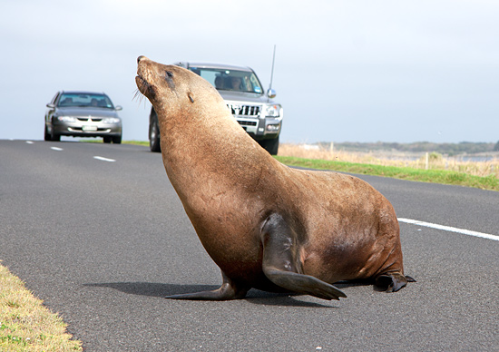 Extensive networks of busy roads hinder the movement of animals  From Rewilding Foundation  http://www.rewildingfoundation.org/rewilding-through-vision/habitat-destruction-biodiversity-loss-and-deterioration-of-the-biosphere/ |  | Details Habitat fragmentation occurs when natural spaces are increasingly reduced, divided and degraded by urbanization -- for example busy roads, canals, and intensive agricultural areas. Reduced and degraded natural areas are inevitably subject to local extinctions of environmentally sensitive plants and animals and the replacement by opportunistic species that put further pressure on the remaining native plants and animals.  Impact  What is left in the divided system are populations (of animals) clinging on to survive in remaining habitat fragments. These populations are vulnerable to further habitat degradation and genetic impoverishment.
Reflection questions: What adaptation would this animal have to make to be able to survive in its changed environment? Behavioral? Physiological? Structural? What would the result be if a species was unable to adapt? How can humans help reduce the impact of their activities on this species?

