http://www.canadianparks.com/bcolumbia/gwaiinp/page9.htm
BC’s Natural Selection, Adaptive Radiation, Endemic Species and Risks to Biodiversity

The Queen Charlottes are often called the ‘Canadian Galapagos’ because of the number of endemic species that have evolved here, distinct from their mainland relatives. The archipelago is also influenced by introduced species which are changing the vegetative and animal profile of the islands.
The Queen Charlotte Islands may have been a refuge for a number of species during the last period of glaciation; however, it is their subsequent isolation that helps explain why so many species have evolved differently here than on the mainland. At least 39 distinct subspecies of plants and animals in the archipelago, including seven mammals, three birds and fifteen species of the stickleback fish are found nowhere else in the world.
- The Haida Gwaii Black bear is a prime example of evolution to adapt to a particular environment. With limited alpine habitat available, the Haida Gwaii bear has developed exceptionally strong jaws in order to take advantage of the abundance of hard shelled sea creatures available. Over thousands of years, the bears with superior crushing ability would be the strongest and therefore most likely to reproduce. As a result of natural selection, on these islands are found the largest black bears in North America.

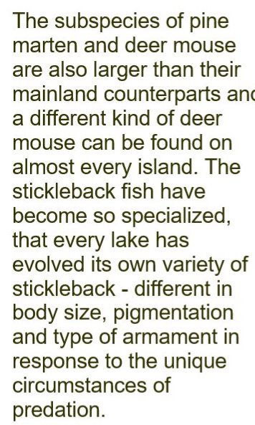Also read article on three-spine sticklebacks.

- A. Threats to endemic species
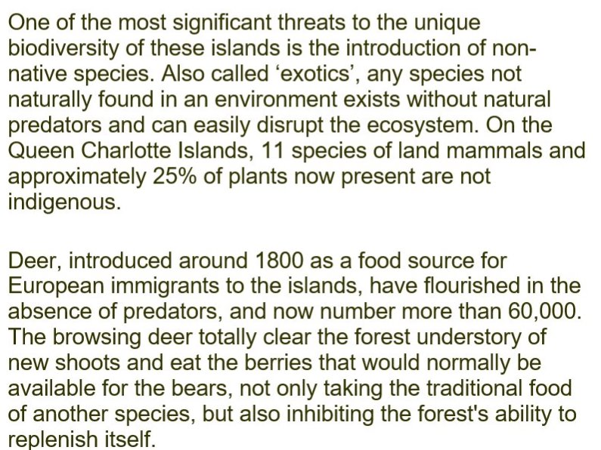
3b.

