Regular Present Tense –ER Verbs
Verbs ending in –ER follow the same rules
 | -ER | Example of –ER verb :  Jouer (to play)
Je | e | joue
Tu | es | joues
Il/Elle/On | e | joue
Nous | ons | jouons
Vous | ez | jouez
Ils/Elles | ent | jouent

Other –er Verbs

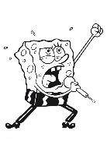
- Adorer- to love
- Chanter- to sing
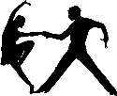
- Danser- to dance
- Détester- to hate
- Discuter- to discuss
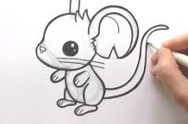
- Dessiner – to draw
- Écouter- to listen
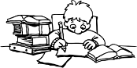
- Étudier- to study
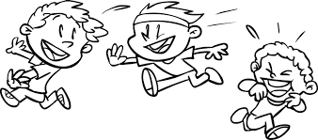
- Jouer- to play
- Manger- to eat
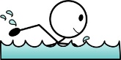
- Nager- to swim
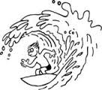
- Parler- to talk
- Surfer – to surf
- Regarder- to watch
- Téléphoner- to call
- Travailler – to work
Note: You only need to change the ending (conjugate verbs) when the word is used as a verb.
I surf in Tofino. (surf is the verb)
Je surfe à Tofino.
vs. I like to surf. (surf is the noun)
J’aime surfer.

