Wolves on B.C.'s islands, mainland genetically different

Heiltsuk people had long known coast and timber wolves as distinct
By By Emily Chung, CBC News Posted: Jun 10, 2014 12:01 AM ET Last Updated: Jun 11, 2014 1:03 AM ET
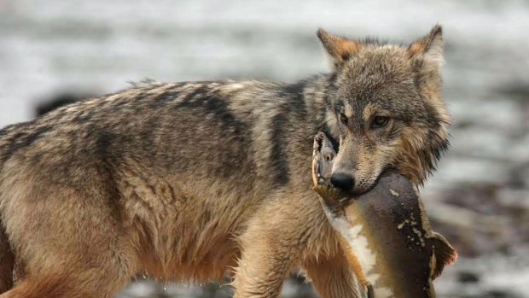
Wolves that live on islands off the B.C. coast eat mostly fish, such as salmon and shellfish such as clams and mussels. (Guillame Mazille/Raincoast Conservation Foundation)
If you are a wolf cub on B.C.'s mainland, your parents will feed you moose, deer and beaver and will teach you to hunt as you get older. If you are a wolf cub on the islands off the B.C. coast, salmon will be on heavy rotation at mealtime, and your parents will teach you to dig clams and catch fish.
Either way, you will likely one day settle down with someone special who was raised the way you were.
That's what a new study by Canadian and Polish researchers shows — that two groups of wolves that live side-by-side along B.C.'s coast live very different lives and don't interbreed much. Statistical tests show they're far more genetically different than expected for such close neighbours.
"They kind of stick to their own," said Chris Darimont, senior author of the paper published today in BMC Ecology.
- Read the full paper in BMC Ecology
Up until recently, scientists didn't think wolves that close to one another would be so genetically different, but Darimont said it makes sense given the wolves' huge differences in behaviour.
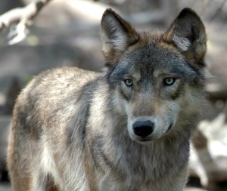
Wolves on B.C.'s mainland hunt deer, moose and beaver. (Dawn Villella/Associated Press)
"Part of the way they're maintained is probably through learning and culture, absolutely," he added. "These are long-lived and intelligent animals."
When he first started studying the wolves 14 years ago, Darimont, a biologist at the University of Victoria and the Raincoast Conservation Foundation, believed there was only one kind of wolf that crossed freely between the islands and the mainland, which were separated by a few hundred metres of water that wolves could easily swim — and do easily swim when crossing between islands.
At that time, Chester Starr, an elder from the Heiltsuk First Nation near Bella-Bella, was helping him in his research.
Starr started off by asking Darimont a question that the scientist thought was "so strange" at the time.
"And that was, 'What wolves are we going to study? The timber wolves' – he kind of looked over to the mainland – 'or the coastal wolves on these islands?'"

Mountains of feces
Starr, 63, told CBC News that his father talked about watching wolves get salmon out of the river. He himself would see them in rivers and estuaries. Over time, as their original territory was logged, the wolves even moved onto islands that they never inhabited before, he added.
"It's not a good habitat," he said. "The deer have pretty much eaten all the vegetation they could eat there."
With Starr's help, over the course of his research, Darimont came to learn how different the wolves of the outer islands were from those of the mainland, mainly by studying samples of their hair and feces.
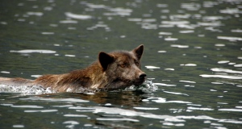
Wolves swim easily between islands, and have no trouble crossing the short distances between the islands and the mainland of B.C. (Chris Darimont/University of Victoria)
"We picked up a lot of feces, mountains of feces — 7,000 [samples] over the decade," Darimont said.
He discovered that wolves on B.C.'s outer islands have a diet that is 90 per cent seafood, including salmon, clams and mussels, and even those in the islands closer to the coast eat as much seafood as meat. Meanwhile, those on the land almost exclusively hunt land animals such as deer, moose and beaver.
Darimont's latest study, led by Astrid Stronen at the Polish Academy of Sciences and Erin Navid at the University of Victoria, show the wolves' genetics mirror that pattern, with little mixing between the outer islands and the mainland, and the wolves on the inner islands somewhere in between.
Although that's interesting, Darimont said that, for him, "the most exciting part of this work is how science and indigenous knowledge, even though they use very different approaches, can often point to the same conclusion."
He added that the people who have lived in the region for millenniums have spent that time observing the wolves and that the new DNA data complements their knowledge.
Darimont thinks the dietary differences among the wolf populations are there because if mainland wolves wanted to eat salmon, they would compete with big, ferocious grizzly bears, which are common on the mainland but rare on coastal islands.
Because the island wolves rely so heavily on seafood such as fish and clams, it means that along with whales and seabirds, they might be vulnerable to a potentially large oil spill, Darimont said.
"We risk losing them and biological diversity within wolves should [a spill] happen."
Environmental groups such as the Raincoast Conservation Foundation, the lead funder of the study, worry about the increased risk of such spills if the Northern Gateway pipeline is approved. The western terminus would be Kitimat B.C., turning the surrounding waters into a major oil shipping channel. A government decision on whether to approve the pipeline is expected this week.
Other funding for the study was provided by the National Geographic Society, the Wilburforce Foundation, the Tula Foundation and the Natural Science and Engineering Research Council of Canada.

